**PROJECT**

**Aim:- To Deploy a Static Website Using AWS.**

**PREREQUISITES:-**

1. **An AWS Account.**
2. **Thorough Knowledge about AWS S3 Service.**
3. **A HTML/CSS/JAVASCRIPT File to upload in the S3 bucket.**

**WHAT IS AWS S3?**

Amazon S3 is a Simple Storage Service in[AWS](https://www.geeksforgeeks.org/aws-tutorial/)that stores files of different types like Photos, Audio, and Videos as Objects providing more scalability and security.  It is probably the most commonly used, go-to storage service for AWS users given the features like extremely high availability, security, and simple connection to other AWS Services.

An Amazon S3 bucket can be set up to operate similarly to a website. Let us now take a look at how we can deploy a static website using AWS.

**STEPS TO DEPLOY A STATIC WEBSITE USING AWS.**

**TASK 1:-** Sign in to AWS Management Console

1. Click on the Open Console button, and you will get redirected to AWS Console in a new browser tab.

2. On the AWS sign-in page,

· Leave the Account ID as default. Never edit/remove the 12-digit Account ID present in the AWS Console. otherwise, you cannot proceed with the lab.

· Now copy your User Name and Password in the Lab Console to the IAM Username and Password in AWS Console and click on the Sign in button.

3.Once Signed In to the AWS Management Console, Make the default AWS Region as US East (N. Virginia) us-east-1.

**TASK 2:-** Creating a S3 Bucket.

1.Navigate to S3 by clicking on the Services menu at the top, then click on S3 in the Storage section.

2. In the S3 dashboard, click on the Create Bucket button.

3. In the General Configuration, Bucket name: Enter abcxyz

· **Note**: S3 Bucket names are globally unique, choose a name that is available. Maybe you can enter your name and create one.

4. AWS Region: Select US East (N. Virginia) us-east-1

5. Object ownership: Select ACLs disabled (recommended) option

6. In the option of Block Public Access settings for this bucket, Uncheck the option of Block all public access.

· Check the I acknowledge that the current settings might result in this bucket and the objects within becoming public checkbox.

7. Keep everything default and click on Create Bucket button.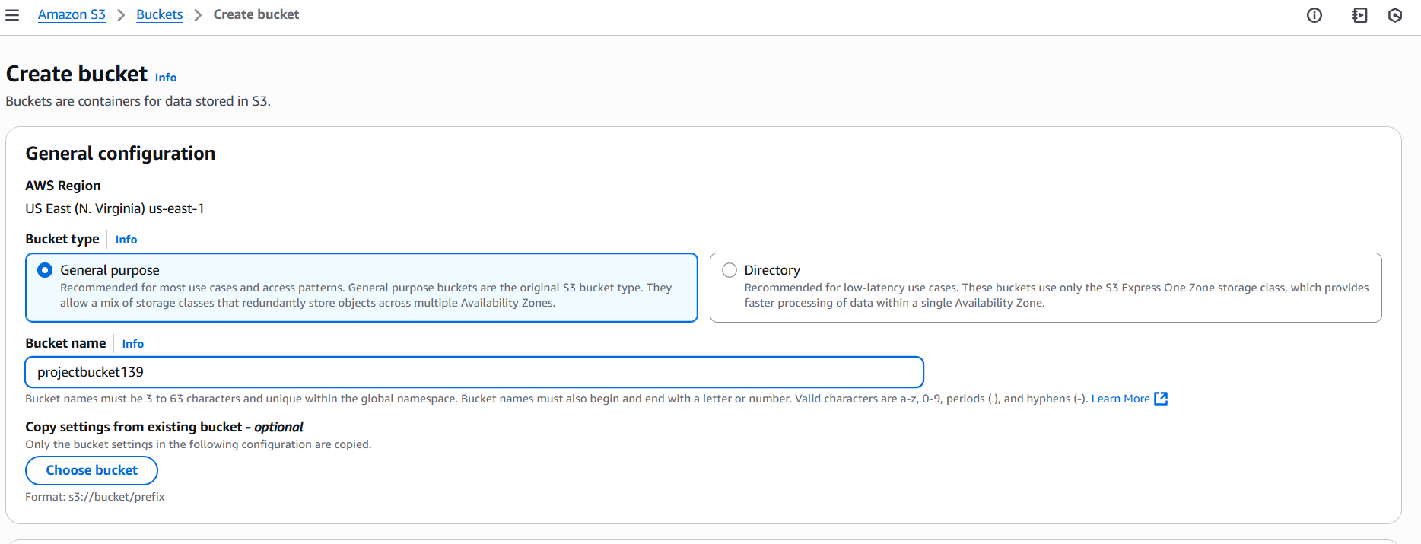

**NOTE:-** In our case we have taken the bucket name as **projectbucket139.**

**TASK 3:-** **:** Enable Static Website Hosting settings.

1. To proceed, go to the S3 bucket name that you created and click on it. After that, navigate to the Properties tab which can be found at the top of the screen.

2. Scroll down to the Static website hosting section and click on Edit button.

3. In the Static website hosting dialog box

· Static website hosting: Select Enable

· Hosting type: Choose Host a static website

· Index document: Type index.html

. Leave other credentials as default and click on save changes.

.**NOTE:-**In the index document section you can also give the name of your html file.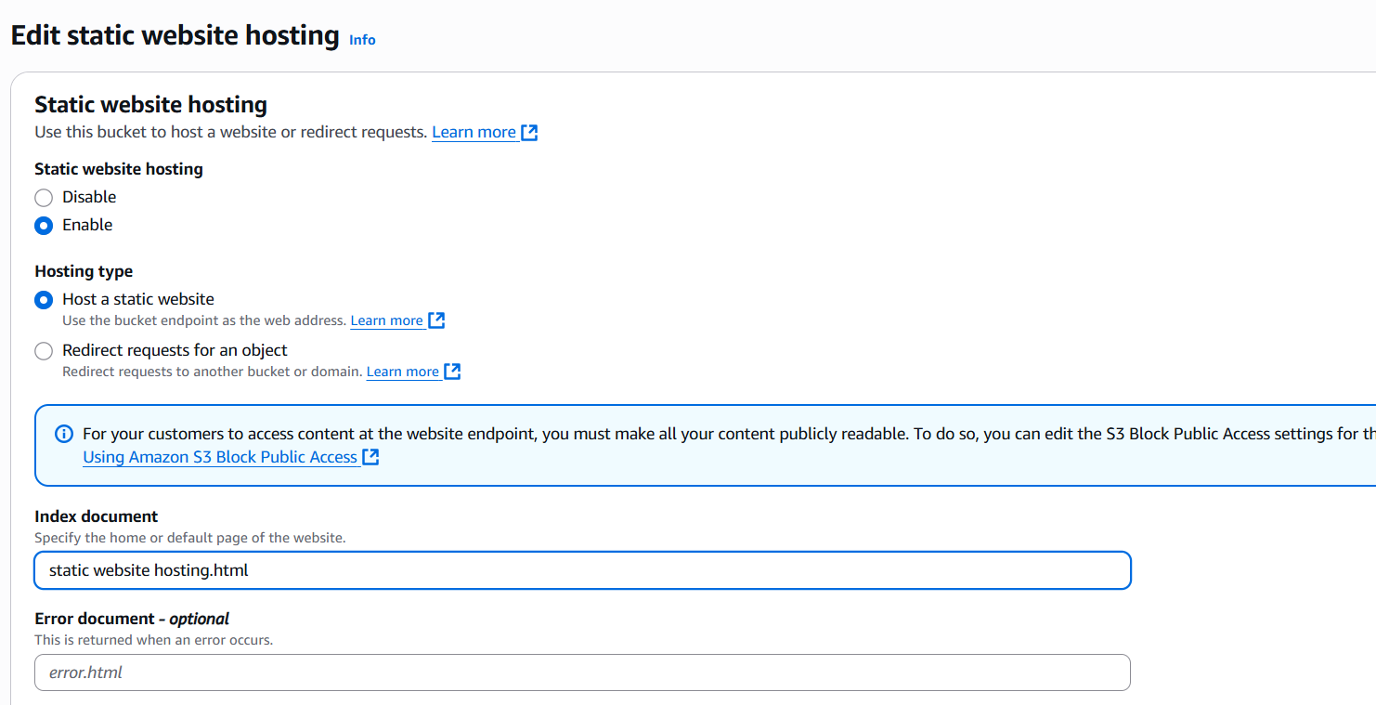

. Here, we have given the name of the html file which we have created using the text editor (Notepad).

**NOTE:-** The error document is optional which is uploaded to give the error message.

4.Go to the Properties tab of your S3 bucket, and find the Static website hosting section. Copy the Endpoint provided in this section to your clipboard and save it for future reference.

5.Now, upload the HTML file to the s3 bucket you have created earlier.

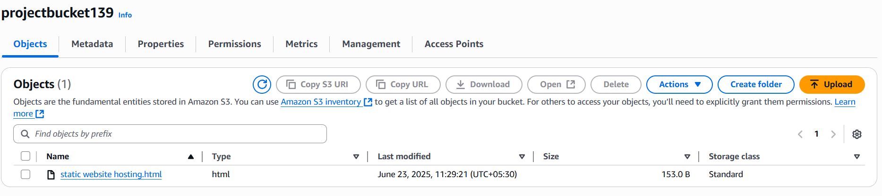

**TASK 4:-** To access the permissions tab in S3 Bucket.

1· In the Permissions tab, Click on the Edit button beside the Bucket Policy.

2· You will be able to see a Blank policy editor.

3· Before creating the policy, you will need to copy the ARN (Amazon Resource Name) of your bucket.

4· Copy the ARN of your bucket to the clipboard. It is displayed at the top of the policy editor. it will look like ARN:“arn:aws:s3:::your-bucket-name".

5· In the policy below, Update the bucket ARN on the Resource key value and paste the below policy code in the editor.

{

"Id":"default",

"Version":"2012-10-17",

"Statement":[

{

"Sid":"Stmt1",

"Action":[

"s3:GetObject"

],

"Effect":"Allow",

"Resource":"replace-this-string-with-your-bucket-arn/*",

"Principal":"*"

}

]

}

6.Click on Save changes button.

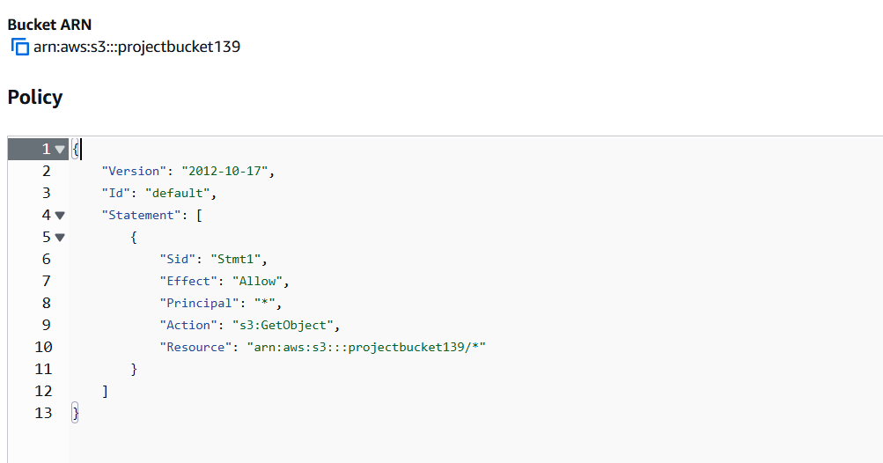

**TASK 5:-** Test The Static Website Created

1. Now copy the static website URL (that we saved earlier) and run it in your browser. You will be able to see the file's text.

**RESULT**

THE STATIC WEBSITE HAS SUCCESSFULLY EXECUTED.

The link of the following website is given below.

<https://projectbucket139.s3.us-east-1.amazonaws.com/quiz.html>